11th Annual Meeting of the Organization for Human Brain Mapping

Partial correlation mapping of cognitive measure and cortical thickness in autism

Moo K Chung^{1,2,3}, Dalton M Kim³, Steven Robbins⁴, Alan C Evans⁴, Richard J Davidson³
¹Department of Statistics, University of Wisconsin-Madison
²Department of Biostatistics and Medical Informatics, University of Wisconsin-Madison
³The Waisman Laboratory for Brain Imaging and Behavior, University of Wisconsin-Madison
⁴Montreal Neurological Institute, McGill University

Abstracts:
We correlated face recognition task scores to cortical thickness measurements in a group of autistic subjects. Many previous autism anatomical studies neglect to account for age effect and the subsequent statistical parametric maps tend to report spurious results. We demonstrate that the partial correlation mapping proposed here can remove the effect of age and global cortical area difference effectively while localizing the regions of high correlation.

Methods:
14 high functioning autistic (HFA) and 12 normal control (NC) subjects used in the study were screened to be right-handed males (Chung, et al., 2004). Face recognition task was performed for the both groups. Age distributions for HFA and NC are 15.93±4.71 and 17.08±2.78 respectively. The face recognition task scores for HFA and NC are 27.14±15.34 and 39.42±0.79 respectively. The outer cortical surface areas are and for HFA and NC respectively. MRIs were collected and both the outer and inner cortical surfaces were extracted for each subject via deformable surface algorithm (MacDonald et al., 2000). Surface normalization is performed by minimizing an objective function that measures the global fit of two surfaces while maximizing the smoothness of the deformation in such a way that the pattern of gyral ridges are matched smoothly (Robbins, 2003). Afterward cortical thickness was computed for each subject (Chung et al., 2005). Heat kernel smoothing was applied to the cortical thickness measures to increase the signal-to-noise ratio with relatively large FWHM of 30mm (Chung et al., 2005). The simple correlation between thickness and score were computed for both groups. To partial out the effect of age and global surface area difference in the correlation, the concept of partial correlation was used (Grunwald et al., 2001).

Results:
Comparing the partial correlation to the simple correlation, there is statistically significant increase in the correlation in many areas indicating that the age and the area terms should be accounted for proper correlation analysis. The partial correlation mapping can remove the effect of the age and global area difference in the simple correlation measure as illustrated in the figure.
Conclusions:
The partial correlation mapping is an effective way of visualizing and localizing the cortical regions of high correlation removing the effect of covariates.
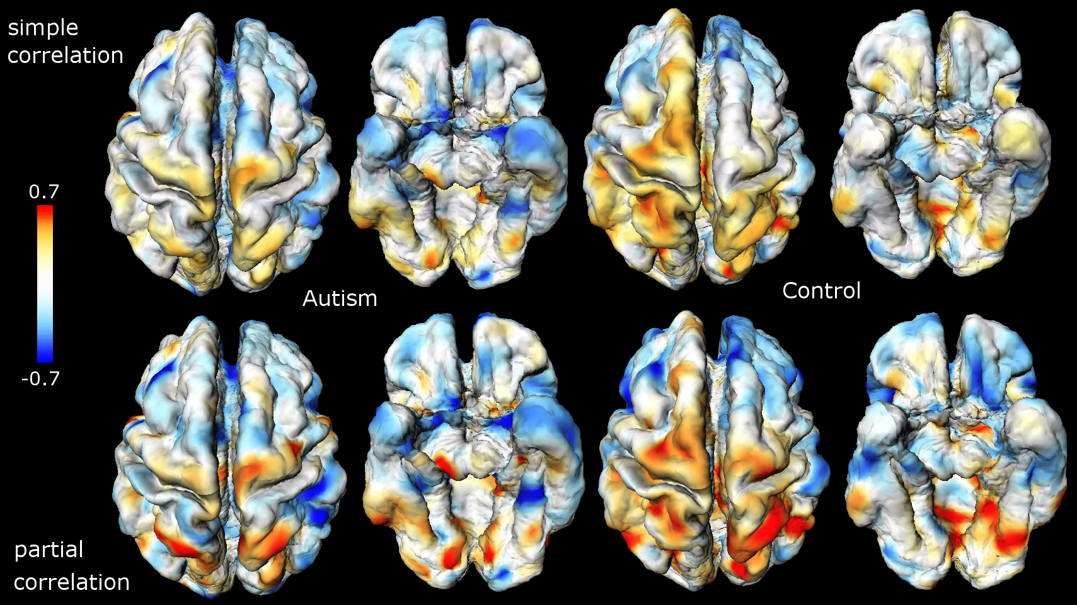
Figure 1. Correlation map of face recognition task and cortical thickness. The partial correlation mapping can remove the effect of the age and global area difference in the simple correlation measure.

References:

[1] Chung, M.K., Robbins,S., Dalton, K.M., Davidson, R.J., Alexander, A.L., Evans, A.C. 2005. Cortical thickness analysis in autism via heat kernel smoothing. NeuroImage. in press.

[2] Chung, M.K., Dalton, K.M., Alexander, A.L., Davidson, R.J. 2004. Less white matter concentration in autism: 2D voxel-based morphometry. NeuroImage 23:242-251.

[3] Grunwald, M., Busse, F., Hensel, A., Kruggel, K., Riedel–Heller, S., Wolf, H., Arendt, T., Gertz, H.- J. 2001. Correlation between cortical θ activity and hippocampal volumes in health, mild cognitive impairment, and mild dementia. Journal of Clinical Neurophysiology 18:178 –184.

[4] MacDonald, J.D., Kabani, N., Avis, D., Evans, A.C., 2000. Automated 3-D extraction of inner and outer surfaces of cerebral cortex from MRI. NeuroImage 12, 340–356.

[5] Robbins, S.M. 2003. Anatomical Standardization of the Human Brain in Euclidean 3-Space and on the Cortical 2-Manifold. PhD thesis, School of Computer Science, McGill University.

