11th Annual Meeting of the Organization for Human Brain Mapping

Introducing heat and geodesic kernel smoothings on cortical manifolds

Moo K Chung^{1,2,3}, Limpiti Tulaya⁴
¹Department of Statistics, Unversity of Wisconsin-Madison
²Department of Biostatistics and Medical Informatics, Unversity of Wisconsin-Madison
³The Waisman Laboratory for Brain Imaging and Behavior, Unversity of Wisconsin-Madison
⁴Department of Electrical Engineering, University of Wisconsin-Madison

Abstract:
Gaussian kernel smoothing has been widely used in 3D medical images as a way to increase signal-to-noise ratio and coloring dependent noise structure for random field theory, in part, due to its simplicity in numerical implementation. Gaussian kernel is isotropic in Euclidian space, i.e., it assigns the same weights to observations equal distance apart. However, data residing on the convoluted brain cortex fails to be isotropic in the Euclidean sense. On the curved surface, a straight line between two points is not the shortest distance so one may incorrectly assign less weights to closer observations. The question we attempt to answer is how to correctly formulate isotropic smoothing for data on the cortical surface.

Methods:
When data lie on a 2D cortical surface, data smoothing must be weighted according to geodesic distance along the surface. One existing approach called diffusion smoothing formulates smoothing as the process of heat diffusion by explicitly solving an isotropic diffusion equation with the given data as an initial condition [1, 2, 3]. The drawback of the diffusion smoothing approach is the complexity of setting up a finite element method and making the numerical scheme stable [4]. To address these shortcomings, we propose a simpler method called heat kernel smoothing and its extension called geodesic kernel smoothing. The heat kernel smoothing is formulated as iterated convolutions between the data and a heat kernel. It can be proven that smoothing with a large bandwidth is equivalent to iterative smoothing with a smaller bandwidth [3]. Furthermore, for a small bandwidth the heat kernel converges locally to a Gaussian kernel. Extending the heat kernel smoothing method, we have developed geodesic kernel smoothing. We first compute the geodesic distance on the cortex using the dynamic programming. Then the geodesic kernel is constructed by assigning weights as a function of the geodesic distance and appropriately normalizing the kernel. This approach avoid the necessity of choosing a small bandwidth so the smoothing can be performed efficiently with less number of iterations and a larger bandwidth.

Results:
Heat kernel smoothing on actual cortical thickness data was performed for illustration. The figure shows smoothing with bandwidth s=1 and 20, 100 and 200 iterations.
Conclusions:
Both heat kernel and geodesic kernel smoothing are effective cortical surface data smoothing techniques.
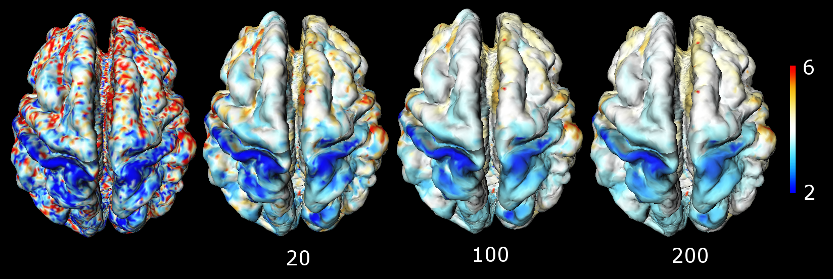
Figure 1. Heat kernel smoothing on actual cortical thickness data. The bandwidth σ = 1 was used with 20, 100 and 200 iterations.

References:

[1] Andrade, A., Kherif, F., Mangin, J., Worsley, K.J., Paradis, A., Simon, O., Dehaene, S., Le Bihan, D., and Poline, J-B. 2001. Detection of FMRI activation using cortical surface mapping, Human Brain Mapping 12, 79-93.

[2] Cachia, A., Mangin, J.-F., Rivi´ere, D., Kherif, F., Boddaert, N., Andrade, A., Papadopoulos-Orfanos, D., Poline, J.-B., Bloch, I., Zilbovicius, M., Sonigo, P., Brunelle, F., R´egis. 2003. A Primal sketch of the cortex mean curvature: a morphogenesis based approach to study the variability of the folding patterns, IEEE Transactions on Medical Imaging 22, 754-765.

[3] Chung, M.K., Robbins,S., Dalton, K.M., Davidson, R.J., Alexander, A.L., Evans, A.C. 2005. Cortical thickness analysis in autism via heat kernel smoothing. NeuroImage. in press.

[4] Chung, M.K., Taylor, J. 2004. Diffusion Smoothing on Brain Surface via Finite Element Method, IEEE International Symposium on Biomedical Imaging (ISBI).

