Human Brain Mapping 2007 Abstract Number 194

Automated Diagnosis of Autism Using Fourier Series Expansion of Corpus Callosum Boundary

Shubing Wang, Moo K. Chung, Kim M. Dalton,
Andrew L. Alexander and Richard J. Davidson
${}^{1}$Department of Statistics
${}^{2}$Department of Biostatistics and Medical Informatics
Department of Medical Physics
Department of Psychology and Psychiatry
Waisman Laboratory for Brain Imaging & Behavior
University of Wisconsin at Madison

1. Introduction

In this paper, we explore the possibility of developing an automatic diagnostic tool for autism purely based on MRI measurements. Since the two previous structural imaging studies [1] [2] strongly suggested there was significant abnormality in the corpus callosum (CC) region, the methodology is concentrated in this area. For this purpose, we have developed a new framework for representing the CC boundary as a Fourier series. The Fourier coefficients can be viewed as a multivariate measurement that characterizes the CC boundary, and later feed into a classification algorithm.

2. Methods

Segmentation. Three Tesla T1-weighted MR scans were acquired for 15 high functioning autistic and 12 control right-handed males. The CC boundary curves were extracted using the gradient vector flow (GVF) snakes [3] on the midsaggital sections of MRI. The GVF snakes have advantages over the traditional snakes with their larger capture range and ability to move into the concavity. (Figure 1).

Parameterization. The extracted CC boundaries were parameterized by arc-length. A new algorithm for computing the arc-length parameterization using curvature is developed. The algorithm reduces the estimation error in computing the arc-length from finite points. Curvatures were computed using the method of calculating curvatures, which is independent of parameterization. Then a curvature-based global shift registration is performed to compute curvature functions to factor out the orientation and translation difference (Figure 2).

Classification. As a data reduction technique, the CC curves were reparameterized by the finite Fourier series on the coordinate functions. The Fourier coefficients were used as predictors in classifying the CC curves into two groups: normal controls and autism. A decision-tree-based classification technique [4] was applied to determine if it was possible to differentiate autism purely based on the shape of CC curves. Regression tree based methods have been widely used in statistical literatures since there is no explicit statistical assumptions about predictor and response variables.

3. Results
With a small sample size of 27 subjects, we still managed to achieve an impressive 15% misclassification rate (85% correct diagnostic rate) consistent with the result of two previous structural imaging studies done on the CC [1] [2]. With the additional social and behavioral measurements, the correct diagnostic rate can improve.

References
[1] Chung et al. (2003) Less white matter concentration in autism: 2D voxel-based morphometry. NeuroImage 23:242-251.
[2] Aleander et al. (2007) Diffusion tensor imaging of the corpus callosum in autism. NeuroImage 34:61-73.
[3]. Xu, C. and Prince, L. (1998). Snakes, shapes and gradient vector flow, IEEE Trans. on Image Proc, 7:359-369.
[4]. Loh, W.Y. (2002). Regression trees with unbiased variable selection and interaction detection, Statistica Sinica, 12:361-386.

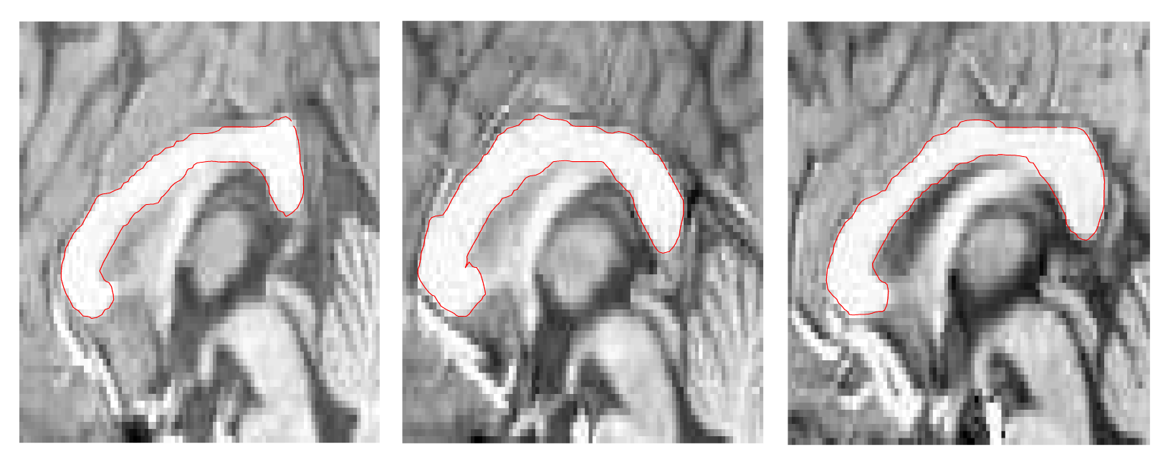
Figure 1.

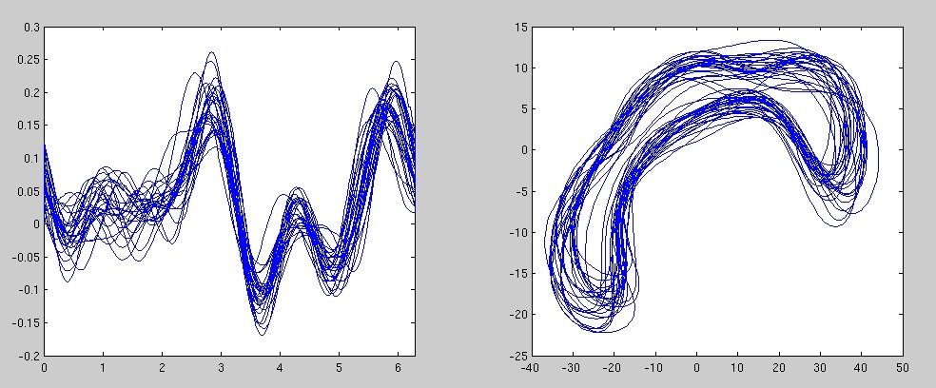
Figure 2.

