Human Brain Mapping Conference 2007 Abstract number 408

Unified Cortical Asymmetry Analysis

in Autism via Weighted-SPHARM
Moo K. chung^{1,2}, Kim M. Dalton², Richard J. Davidson^{2,3}
¹Department of Biostatistics and Medical Informatics
²Waisman Laboratory for Brain Imaging and Behavior
³Department of Psychology and Psychiatry
University of Wisconsin-Madison

1. Introduction
We present the first systematic and unified study of cortical asymmetry in autism using the newly developed weighted-SPHARM representation (Chung et al., 2007). The weighted-SPHARM is a smoothing technique given explicitly as a weighted linear combination of spherical harmonic basis. This new representation is used to parameterize cortical surfaces, establish hemispheric correspondence, and normalize cortical surfaces. The novelty of our approach is that the inherent angular symmetry of spherical harmonics is used in establishing the inter-hemispheric correspondence avoiding additional steps of mirroring 3D MRI and redoing 3D volume based registration, which usually causes sulcal misalignment.
2. Methods
Data. Three Tesla T1-weighted MR scans were acquired for 16 high functioning autistic and 12 control right-handed males. The average ages are 17.1 ± 2.8 and 16.1 ± 4.5 for control and autistic group respectively. After a sequence of image preprocessing steps, both inner and outer cortical surfaces were extracted as fine triangle meshes.
Surface parameterization. The weighted-SPHARM was used to smooth out noisy cortical thickness as well as the three Cartesian coordinates of outer cortical surfaces. Up to 42 degree harmonics were used in representing the data. The first row in Figure 1 shows the weighted-SPARM representation of cortical thickness at k=1, 7, 14, 42 degrees respectively. The second row shows the spatial resolution at that particular degree.
Surface registration. A surface registration is done by simply matching the coefficients of the spherical harmonic bases among weighted-SPHARM representations. This SPHARM-correspondence is optimal in the least squares sense. The average surface, which serves as a template for constructing statistical parametric maps (SPM) in Figure 3, is constructed by averaging in the SPHARM-correspondence.
Cortical asymmetry index. The hemispheric correspondence was established using the SPHARM-correspondence as well as the inherent angular symmetry of spherical harmonics. It turns out the usual asymmetry index A=(L-R)/(L+R) defined on the left hemisphere can be simply expressed as the ratio between the sum of positive order harmonics and the sum of negative order harmonics. This remarkable result was used to construct the asymmetry index without any image flipping or 3D image registration. As a mathematical convention, negative value is assigned on the right hemisphere. Figure 2 shows the asymmetry index for 3 selective subjects. f is cortical thickness. F is the weighted-SPHARM of cortical thickness. F-F* and F+F* are the asymmetric and the symmetric parts of cortical thickness respectively.

Statistical analysis. The two sample t-test with equal variance assumption was used to test for the asymmetry difference between the groups. The t-statistic map and the corresponding P-value map (corrected using random field theory) were constructed and projected onto the average surface (Figure 3). The corrected P-value map shows statistically significant hemispheric asymmetry in two focalized regions (central sulcus and prefrontal cortex).
Reference

Chung, M.K., Dalton, K.M., Shen, L., Evans, A.C., Davidson, R.J. 2007. Weighted Fourier Series Representation and its application to quantifying the amount of gray matter. Special Issue on Computational Neuroanatomy, IEEE Transactions on Medical Imaging. In press.

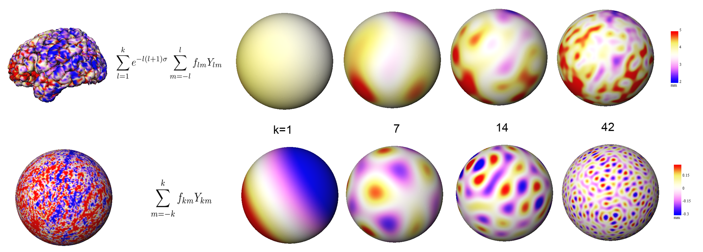Figure 1.
Figure 2.

Figure 3.

