 | 8th Image Analysis Group Meeting  Friday December 5, 2003 at 4:00pm in CS&S 4310

Adaptive anisotropic diffusion denoising of dose distributions and CT images

Robert Jeraj, Ph.D.

Assistant Professor
Departments of Medical Physics and Human Oncology
University of Wisconsin - Madison

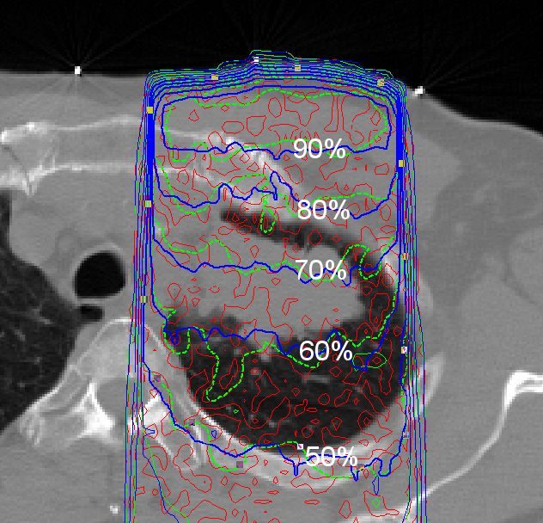

The Monte Carlo transport method is the most accurate method for radiotherapy dose calculations. However, any Monte Carlo dose calculation is burdened with statistical noise. Similarly, reduction of imaging dose to the patient can result in noisy CT images. A simple, but powerful denoising with a three-dimensional adaptive anisotropic diffusion method will be presented. The standard anisotropic diffusion method was extended by changing the filtering parameters adaptively according to the local statistical noise. In addition to the adaptive anisotropic diffusion method, examples of wavelet filtering will be shown for the comparison. Smoothening of dose distributions with different noise levels in phantoms and clinical cases, and smoothing of noisy MVCT images of different imaging phantoms will be shown. It was found out that adaptive anisotropic diffusion method could reduce statistical noise significantly, while well preserving important gradients of the signal. The choice of free parameters of the method was found to be fairly robust.

Everyone is welcome. If you like to give a talk next semester or be on email list, please contact Moo Chung mchung@stat.wisc.edu.

