 | 12th Image Analysis Seminar  Friday November 19, 2004 at 3:00pm in  Waisman Center T137.

What makes a brain autistic?

Brendon M. Nacewicz
W.M. Keck Laboratory for Functional Brain Imaging and Behavior
Waisman Center for Developmental Disabilities
Neuroscience Training Program/UW Medical School
University of Wisconsin-Madison

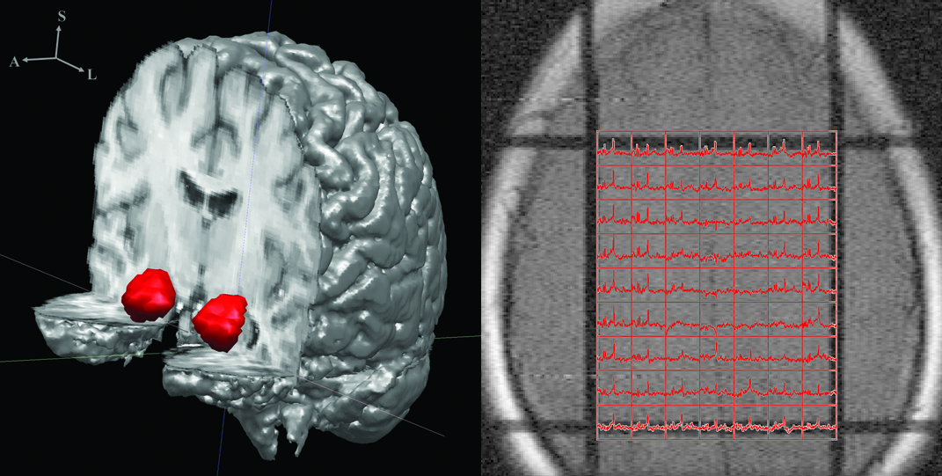

My talk will briefly review the behavioral and functional imaging data that inspired our hypothesis-driven analysis of brain structure in autism. I will describe our analysis of amygdala volume in autism and its relation to the general phenotype. I will then discuss possible implications of these findings and the implementation of more sophisticated structural imaging techniques (diffusion tensor imaging and magnetic resonance spectroscopy) to try to make predictions about the tissue level differences in the brains of autistic individuals.

Everyone is welcome. If you like to give a talk or be on the mailing list, please contact Moo Chung mchung@stat.wisc.edu.

