 | Image Analysis Seminar  Friday February 24, 2005 at 3:00pm  in Waisman Center T137

Magnetic Resonance Image Segmentation

with Thin Plate Spline Thresholding

Xianhong Xie

Department of Statistics
University of Wisconsin-Madison

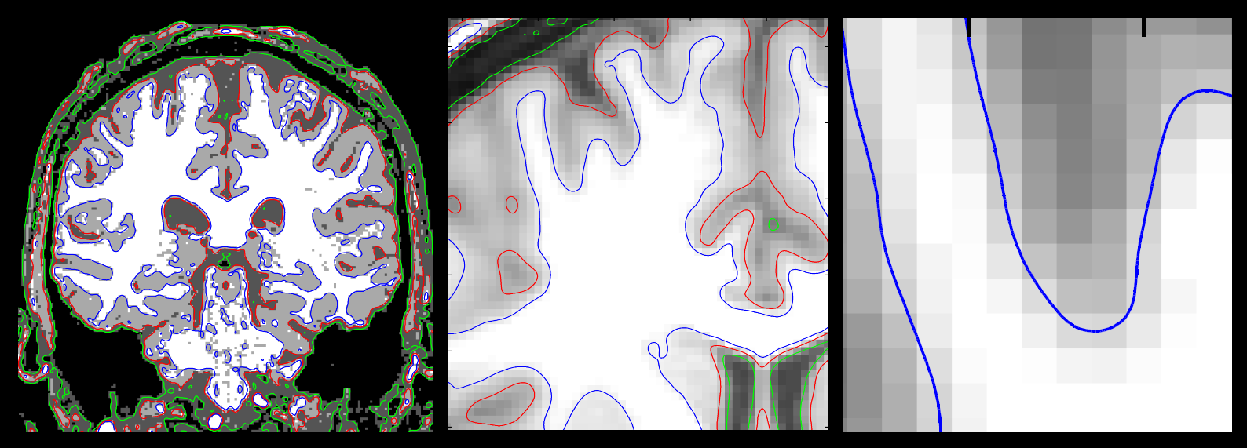

Magnetic resonance image (MRI) segmentation is an important field in neuroimaging. The segmentation can be used for disease diagnosis, surface rendering, and statistical analysis. In my talk, I will describe a new method for T1-weighted MRI segmentation. Each image slice is subdivided into overlapping blocks and a thin plate spline (TPS) is fitted in each block with different number of knots and smoothing parameters. The smoothing parameters are determined automatically using generalized cross validation with a fudge factor. TPS across blocks are blended together smoothly. We have validated our method on MGH CMA 20 normal data. The results show that our method is comparable to widely available SPM2 software result, and is doing reasonably well with respect to manual segmentation. Our method has some other advantages, such as handling of partial volume effects and subpixel level segmentation. This is a joint work with Drs. Grace Wahba and Moo K. Chung.

Please contact Moo Chung mchung@stat.wisc.edu for image analysis seminar mailing list.

