 | Image Analysis Seminar  Friday September 16, 2005 12:00-1:00pm  In 6205 MSC

Functional Representation of Complex Anatomical Shapes in Medical Imaging

Shubing Wang, Moo K. Chung

Department of Statistics & Biostatistics and Medical Informatics

Waisman Laboratory for Brain Imaging and Behavior
University of Wisconsin-Madison

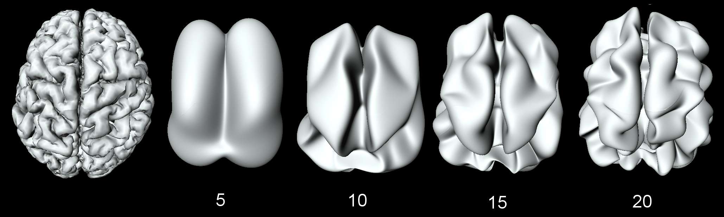

We present a new method of representing complex anatomical boundaries in
medical images using a generalized Fourier series expansion. Anatomical
boundaries that are topologically equivalent to either one or two spheres
(boundaries of tumor, corpus callosum, hippocampus and human brain cortex)
can be represented in this fashion. There are three main advantages for using this new representation. The previously developed cut-and-map technique simply cuts the boundary and map the boundary in the Cartesian coordinates causing the boundary effect. The resulting statistical analysis near the boundary is not reliable. Since there is no cutting involved in our representation, there is no boundary effect. The Fourier expansion gives a natural way of data reduction and
modeling. In this framework, we analyze the coefficients of the series
expansion rather than the coordinates of the boundary providing a unified
modeling framework. The expansion can be modeled in a linear model or the
random field theory frameworks.
Please contact Moo Chung mchung@stat.wisc.edu for image analysis seminar mailing list.

