 | Image Analysis Seminar  Friday September 30, 2005 3:00-4:00pm  In Waisman Center T137

Automatic Classification of High Angular Resolution Diffusion Data and Estimation of Fluid Velocity from Phase Contrast MRI

John Carew

Department of Statistics
University of Wisconsin-Madison

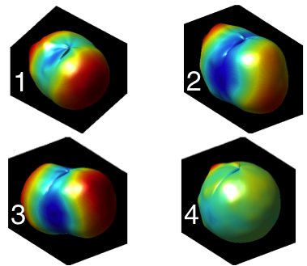

High angular resolution diffusion-weighted imaging (HARD) data can provide information about diffusion in voxels that intersect one or more white matter fibers. The diffusion measurements can be interpreted as noisy samples from the fiber orientation distribution function (ODF), which is defined on the surface of a sphere. Since the ODF can be complicated, it is difficult to visualize on a large
scale. For many voxels a single tensor model may be adequate, but it is difficult to automatically identify these voxels. It is also difficult to characterize how the HARD measurements differ between populations of subjects (e.g., patients vs. controls). To address these problems we propose a method to automatically classify HARD data based on the shape of the ODF.
Phase contrast MRI(PCMRI) is sensitive to fluid velocity. I will describe a nonparametric method to estimate fluid velocity from PCMRI data. Applications to blood velocity and shear in arteries and cerebrospinal fluid velocity in Chiari malformation patients will be presented.

Please contact Moo Chung mchung@stat.wisc.edu for image analysis seminar mailing list.

