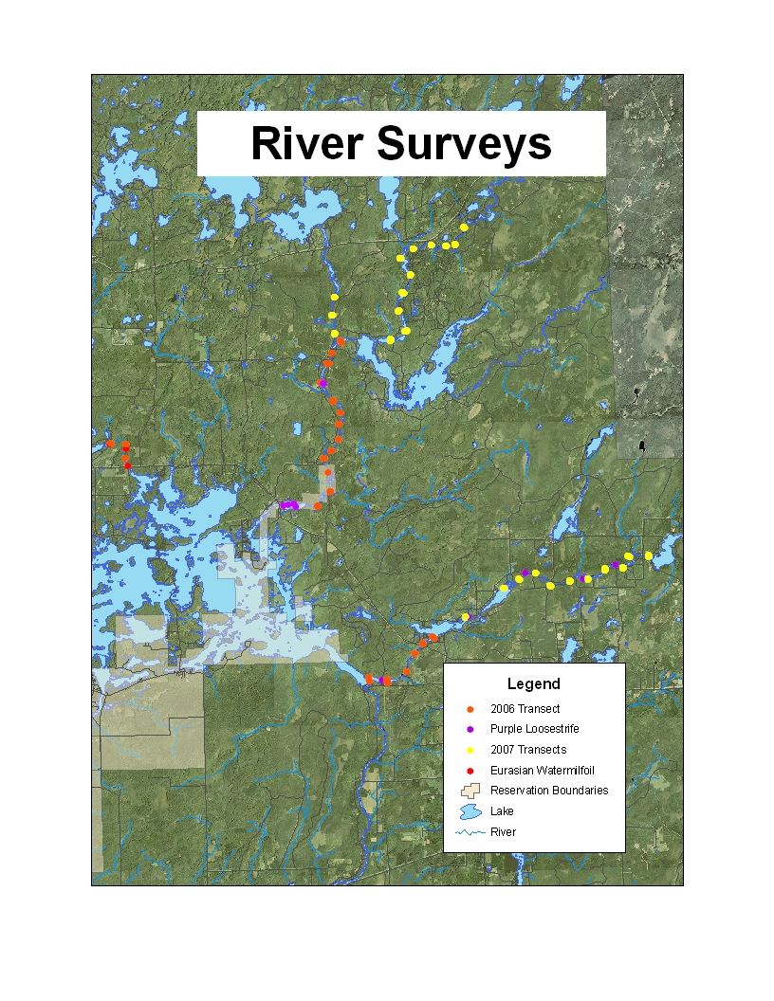

**Chippewa Flowage**

**Figure 1** River survey transects relative to each other and the Chippewa Flowage, and purple loosestrife and Eurasian watermilfoil infestations. Eastfork of the Chippewa River completed in 2006 and 2007 is the southernmost set of transects flowing into the Chippewa Flowage. Northfork of the Chief River completed in 2006 is the set of three transects to the far west. Teal River completed in 2007 is the set of 3 transects flowing into the Westfork of the Chippewa River.

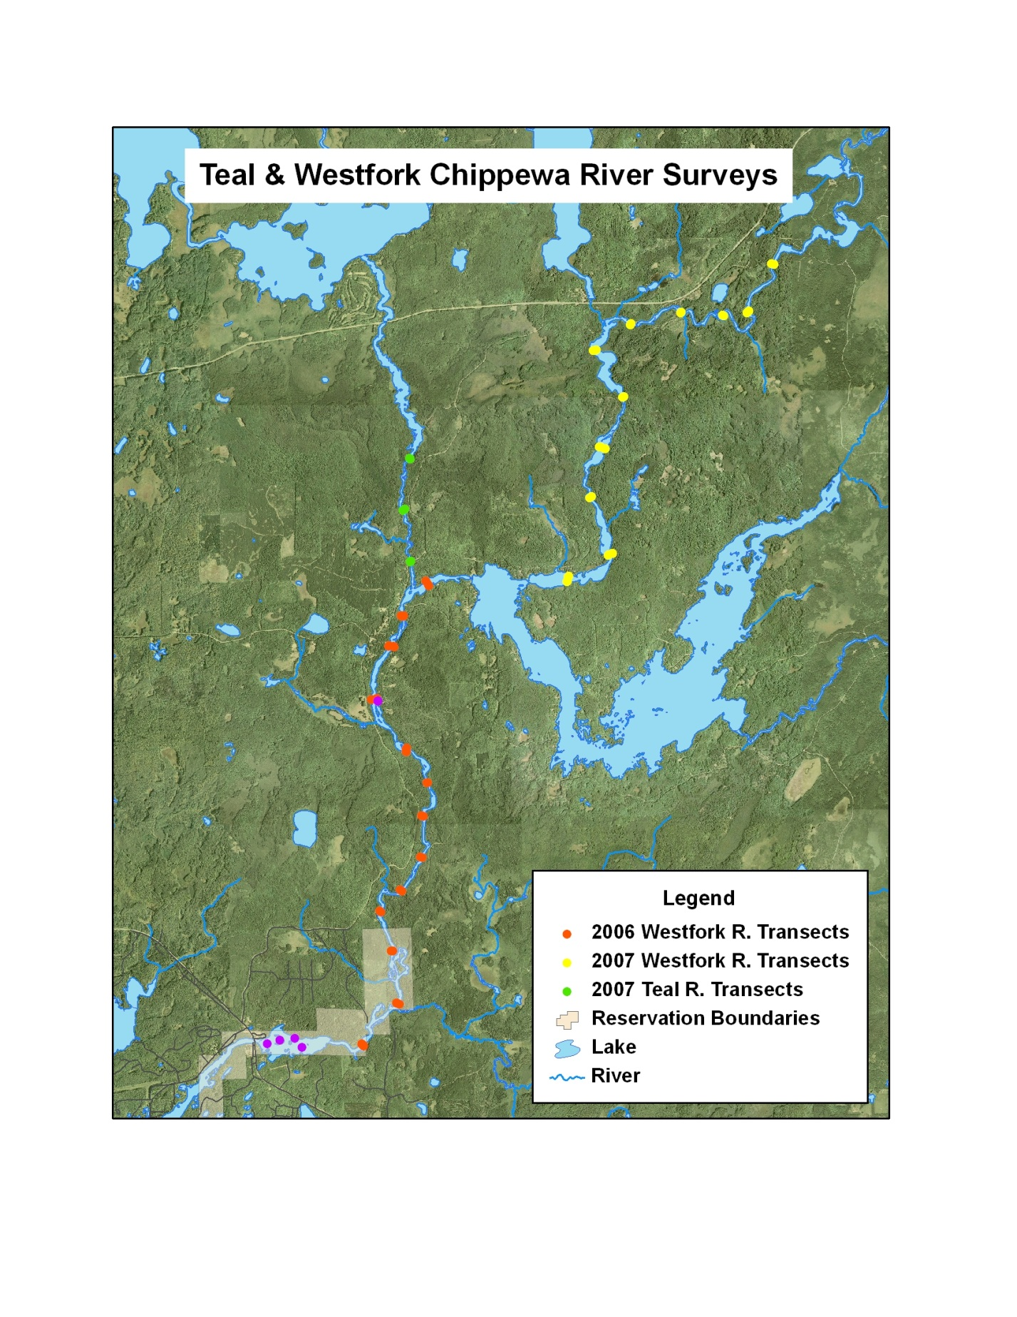

**Figure 2** Westfork of the Chippewa River and Teal River survey transects, purple loosestrife infestations (purple dots) and direction of flow (yellow arrows).

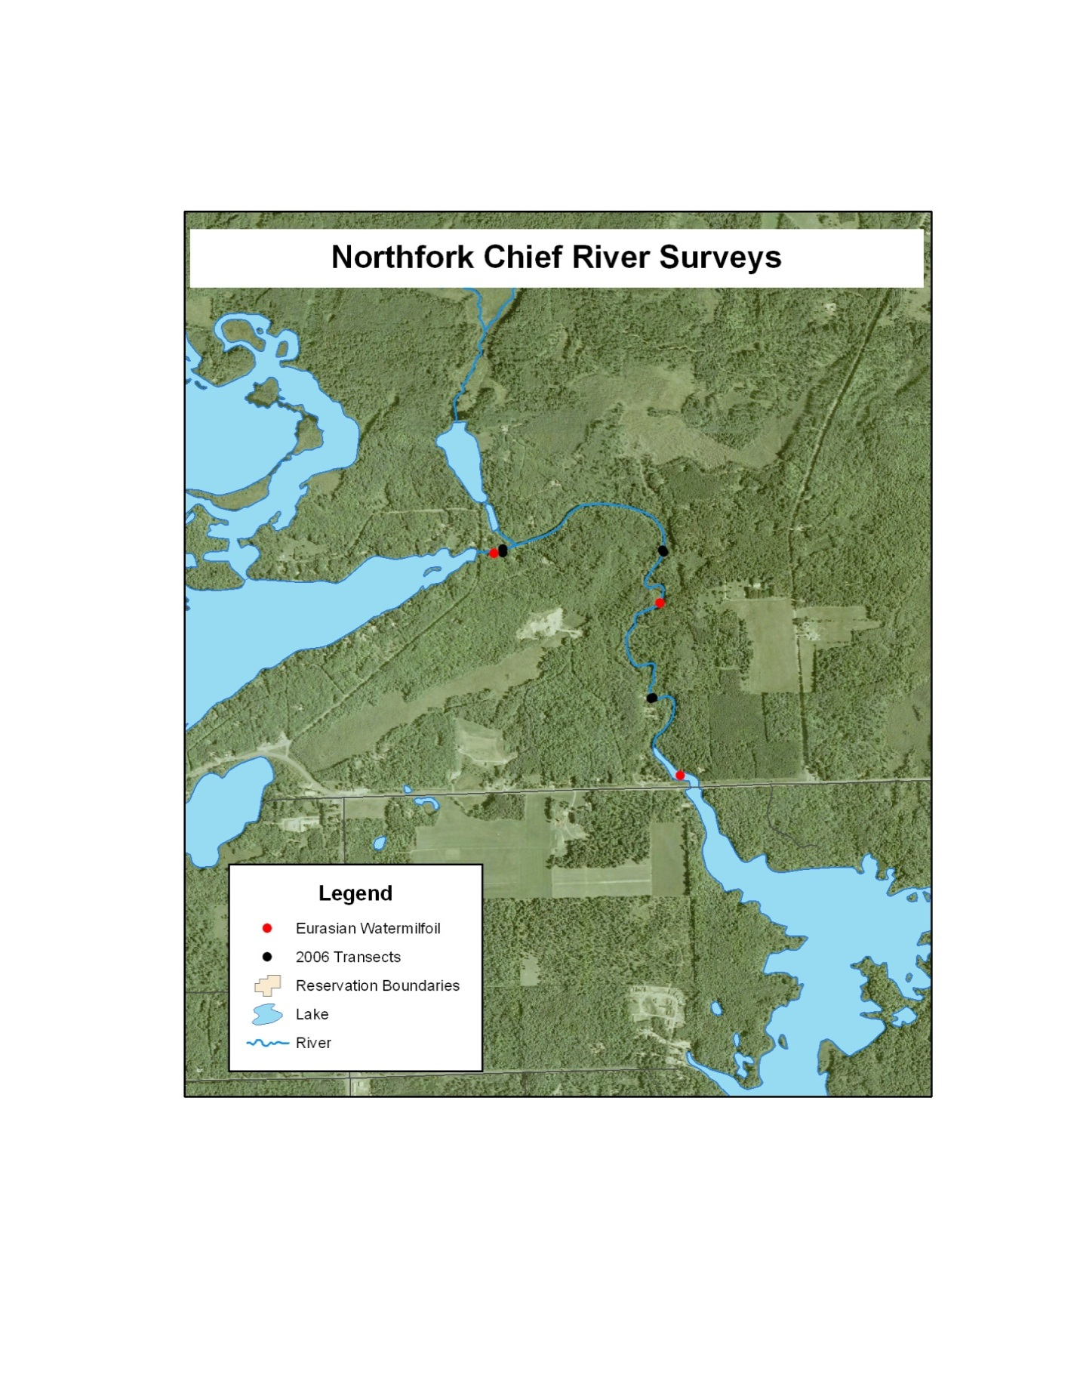

**Figure 3** Northfork of the Chief River survey transects, Eurasian watermilfoil infestations, and direction of flow (yellow arrows).

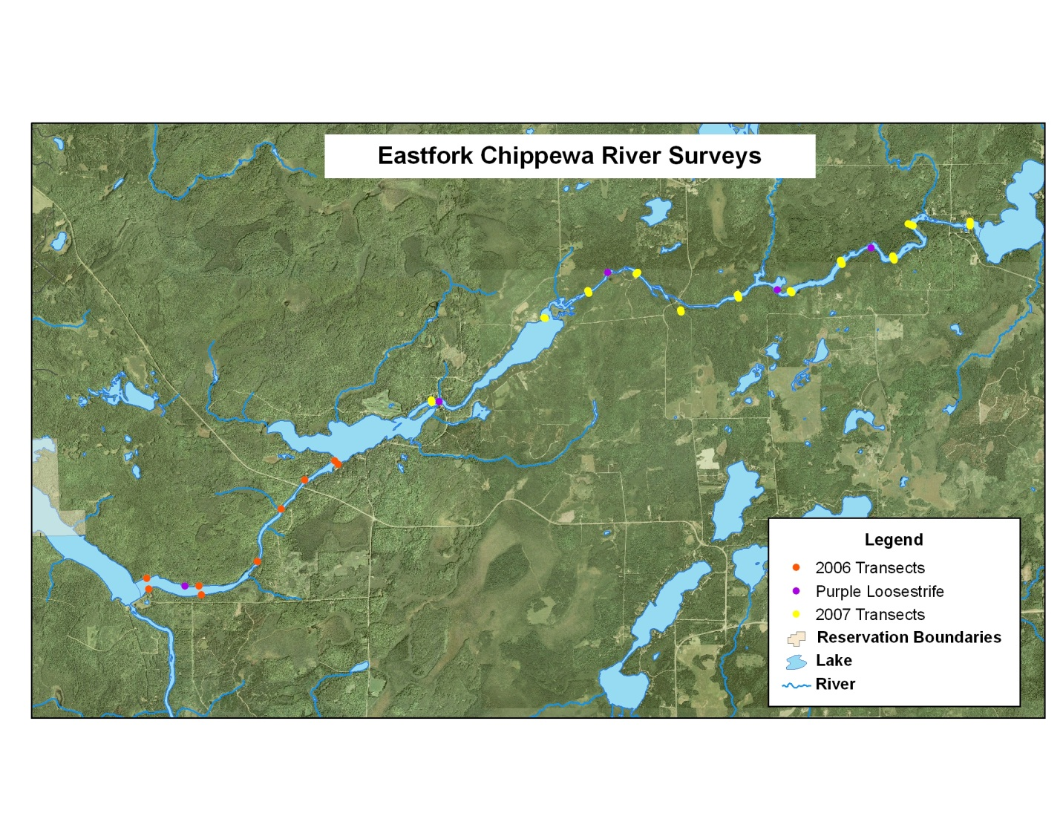

**Figure 4** Eastfork of the Chippewa River survey transects, purple loosestrife infestations and direction of flow (yellow arrows).